**MQ3 Alcohol Sensor using arduino**

Introduction

MQ3 is one of the most commonly used sensors in the MQ sensor series. It is a Metal Oxide Semiconductor (MOS) type of sensor. Metal oxide sensors are also known as **Chemiresistors**, because sensing is based on the change of resistance of the sensing material when exposed to alcohol. So by placing it in a simple voltage divider network, alcohol concentrations can be detected.

Component

Ardiuno uno

MQ -3 alcohol sensor

Connecting wires

breadboard

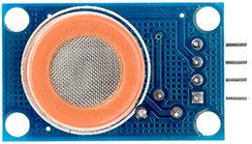

VCC supplies power for the module. You can connect it to 5V output from your Arduino.

GND is the Ground Pin and needs to be connected to GND pin on the Arduino.

D0 provides a digital representation of the presence of alcohol.

A0 provides analog output voltage in proportional to the concentration of alcohol

**Application**

Gas **Sensor**(**MQ3**) module is useful for gas leakage detection (in home and industry).

It is suitable for detecting Alcohol, Benzine

Used in alcohol checker, Breathalyser.

**Objective**

During this activity ,you will help students to achieve following objectives

1. Understanding the principle and operation of MQ-3 sensor
2. Design algorithm and flowchart to detect alcohol present
3. Programming MQ-3 sensor using Arduino uno
4. interfacing MQ-3 sensor using Arduino uno

**Programming steps**

1.initialis variable sensor value to store sensor value

2.initialise serial port for serial communication

3.read digital output pin,if sensor value is detected,then display message [ALCOHOL: DETECTED]

4.else display[ALCOHOL :-]

**Program**

#define MQ3pin 8

int sensorValue; //variable to store sensor value

void setup() {

Serial.begin(9600); // sets the serial port to 9600

Serial.println("MQ3 warming up!");

delay(20000); // allow the MQ3 to warm up

}

void loop() {

sensorValue = digitalRead(MQ3pin); // read digital output pin

Serial.print("Digital Output: ");

Serial.print(sensorValue);

// Determine the status

if (sensorValue) {

Serial.println(" | Alcohol: -");

} else {

Serial.println(" | Alcohol: Detected!");

}

Hardware

Instructions

1. Connect VCC and GND of MQ-3 sensor to 5v supply pin and GND pin of arduino
2. connect signal out pin of sensor to digital pin 8 of arduino

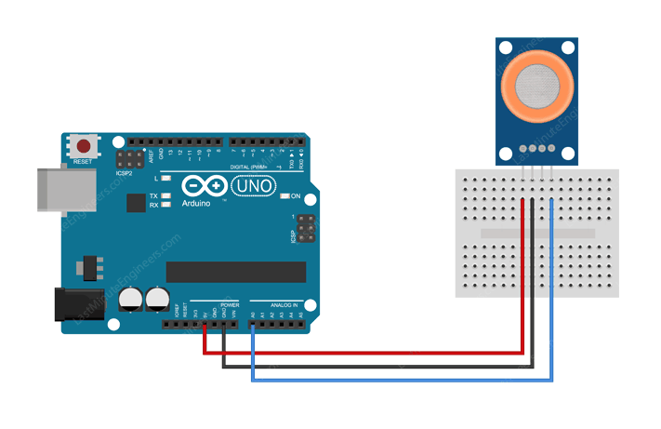

Circuit diagram

